STA2023 – Statistical Methods I
Instructor: Dr. Emil Agbemade
Chapter 4. Probability
Table of Contents
Learning Objectives: 2
4.1 Probability Rules 3
Basic Rules of Probability 5
Methods to Determine Probabilities 7
4.2 The Addition Rule and Complements 10
Addition Rule for Disjoint Events 11
The General Addition Rule 12
Complement of an Event 14
4.3 Independence and the Multiplication Rule 16
Multiplication Rule for Independent Events 17
Computing At-Least Probabilities 18
4.4 Conditional Probability and the General Multiplication Rule 19
Conditional Probability Rule 20
General Multiplication Rule 22
Determining Independence 25
4.5 Counting Techniques 26
General Counting Principle 26
Permutations 28
Combinations 30
Using Counting Methods in Probability Calculations 31
4.7 Determining Which Method to Use 33

Learning Objectives:
By the end of this chapter, students should be able to:
- Understand the random process and apply basic rules of probabilities.
- Compute and interpret probabilities using the empirical, classical, and subjective methods.
- Apply the addition rule for disjoint events and the general addition rule.
- Compute the probability an of event using the Complement Rule
- Identify independent events.
- Use the multiplication rule for independent events and the general multiplication rule.
- Compute at-least probabilities.
- Solve counting problems using the multiplication rule, permutations, and combinations.
- Determine the appropriate probability and counting technique to use.

4.1 Probability Rules
“What’s the chances that happened?!”
- The word “random” suggests an unpredictable result. Predicting random outcomes can be very challenging, such as predicting if a coin will be heads on the next flip. However, if we flipped a coin many times, we would be able to determine the long-term proportion of times a head is observed.
- Definition: A random process refers to a situation where the outcome cannot be predicted with certainty for a single trial.

- Consider a coin being flipped.
  - On the first flip, we flipped tails (0 heads out of 1). The proportion of heads is 0/1 = 0.
  - On the second flip, we flipped heads (1 heads out of 2). The proportion of heads is 1/2 = 0.5.
  - On the third flip, we flipped heads (2 heads out of 3). The proportion of heads is 2/3 = 0.667.
- This process is then repeated for 100 coin flips.
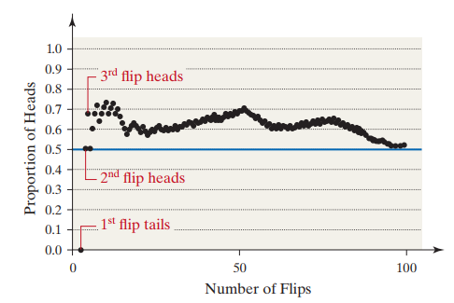
  - After 100 flips, we can see the proportion of heads is just above 0.50.
  - What are the chances of flipping a head on this coin?

- Definition: Probability is a measure of the likelihood of a random event happening. It represents the long-term proportion of times a particular outcome is observed if the experiment is repeated many times.

How do we figure out probabilities? How do we apply probabilities? We have some terminology to describe probabilities and the events we apply probabilities to.

- Definition: An experiment is any process with uncertain results that can be repeated.
Examples:

- Definition: The sample space, S, the collection of all possible outcomes of an experiment.
Example:

- Definition: An event is any collection (subset) of outcomes from the sample space that we are interested in.
Events are usually represented by capital letters like A,B,C,E,F,GA, B, C, E, F, GA,B,C,E,F,G.
A simple event is an event with only one outcome.

EXAMPLE 1: A probability experiment consists of rolling a single fair six-sided die.
- Identify the outcomes of the probability experiment.
- Determine the sample space.
- Define the event E = “roll an even number.”

EXAMPLE 2: The color of a plain M&M milk chocolate candy can be brown, yellow, red, blue, orange, or green. Suppose a candy is randomly selected from a bag.
- Identify the outcomes of the probability experiment.
- Determine the sample space.
- Define the event E = “selects a red or blue M&M.”

Basic Rules of Probability
Notation:

Basic Two Rules of Probability:

- The probability of any event must be between 0 and 1:

- The sum of probabilities of all possible outcomes in the sample space must equal 1:

A probability model lists:
- All possible outcomes (sample space)
- The probability assigned to each outcome

An unusual event is one that has a low probability of occurring, usually:

Example:
If there’s only a 3% chance of drawing a certain color M&M, that would be considered unusual.

EXAMPLE 3: A probability experiment consists of rolling a single fair six-sided die. The probability model is shown below.
Side Rolled | Probability
1 | 1/6
2 | 1/6
3 | 1/6
4 | 1/6
5 | 1/6
6 | 1/6

Verify that the probability model above is a valid probability model.

EXAMPLE 4: Consider the two probability models below. Determine which probability models are valid.

Event | Probability
A | 0.50
B | 0.50
C | 0

Event | Probability
A | 0.40
B | 0.20

Event | Probability
A | -0.10
B | 0.40
C | 0.60
D | 0.10

Methods to Determine Probabilities
Generally, if we want to determine the probability of some event occurring, we have three methods in practice:
- Empirical Method
- Classical Method
- Subjective Method

Empirical Method
- This method relies on relative frequency on data already obtained.
- To approximate probabilities using the empirical approach:

EXAMPLE 6: The table below represents the results of a survey in which 200 people were asked their means of travel to work.
- Use the survey data to build a probability model for means of travel to work.
- Estimate the probability that a randomly selected individual carpools to work. Interpret the results.
- Would it be unusual to randomly select an individual who walks to work?
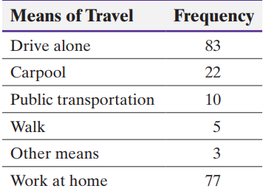

EXAMPLE 7: Refer back to the M&M example. Suppose that a few bags of M&M’s are opened and you record the following results in the table below.
- Use the data below to build a probability model for M&M color.
- Estimate the probability of selecting a red M&M.
Color | Frequency
Brown | 13
Yellow | 14
Red | 13
Blue | 24
Orange | 20
Green | 16

Classical Method
- The classical method does not require a probability experiment to be actually performed. Instead, it relies on counting techniques.
- This method requires equally likely outcomes.
- Using the classical method:

Example 8: A fair coin is flipped two times. Using the classical method,
- Determine the sample space of the experiment.
- Compute the probability of the event “two heads are flipped.”
- Compute the probability of the event “at least 1 tails is flipped.”

Example 9: Suppose that you have two additional tickets to a concert, but you have four potential friends to bring: Adam, Ben, Sam, and Dustin. To be fair, you randomly select two of your friends to go.
- Determine the sample space of the experiment.
- Compute the probability of the event “Adam and Ben go the concert.”
- Compute the probability of the event “Ben goes to the concert.”

Subjective Method
Definition: A subjective probability

- Note that this method is a perfectly legitimate method and sometimes is the only method of assigning probabilities to events.
- For example, and economist may be asked to predict the likelihood the economy will fall into recession next year. We can’t conduct an experiment “n” times and count the number of years in which the economy fell into a recession.

4.2 The Addition Rule and Complements
- In the upcoming sections, we generally care about two events. There are different probability rules depending on how these two events are related.
- Definition: Two events are disjoint if

- We can use Venn diagrams to show the relationship between two events.

Example 10: Suppose we randomly select chips from a bag. Each chip is labeled 0, 1, 2, 3, 4, 5, 6, 7, 8, 9. Let E represent the event “choose a number less than or equal to 2,” and let F represent the event “choose a number greater than or equal to 8.”

Addition Rule for Disjoint Events
Definition: If E and F are disjoint events, then

Example 11: Suppose that a single card is selected from a standard 52-card deck, such as the one shown below:
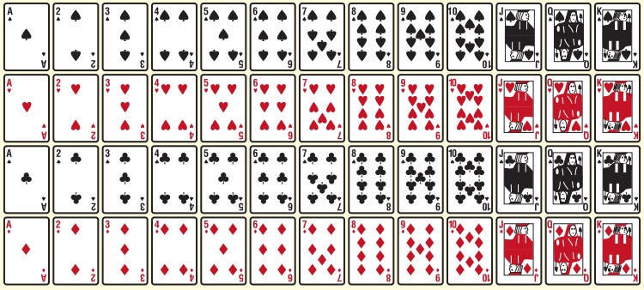
- Compute the probability of the event E = “drawing a king.”
- Compute the probability of the event E = “drawing a king” or F = “drawing a queen” or G = “drawing a jack.”
- Compute the probability of the event A = “drawing a heart” or B = “drawing a diamond.”

The General Addition Rule
- What happens if we want to find P(E and F), but they aren’t disjoint?
Suppose we are randomly selecting chips from a bag. Each chip is labeled 0, 1, 2, 3, 4, 5, 6, 7, 8, or 9. Let E represent the event “choose an odd number,” and let F represent the event “choose a number less than or equal to 4.” Because the events have the outcomes 1 and 3 in common, the events are not disjoint.

Definition: The general Addition Rule
For any two events E and F:

Example 12: Suppose a single card is selected from a standard 52-card deck. Compute the probability of the event E = “drawing a king” or F = “drawing a diamond.”

Probabilities can also be calculated from contingency tables which relate two categories of data. There is a row variable and a column variable.

Example 13: Consider the table below represent he marital status of males and females 15 years old or older in the US in 2021.

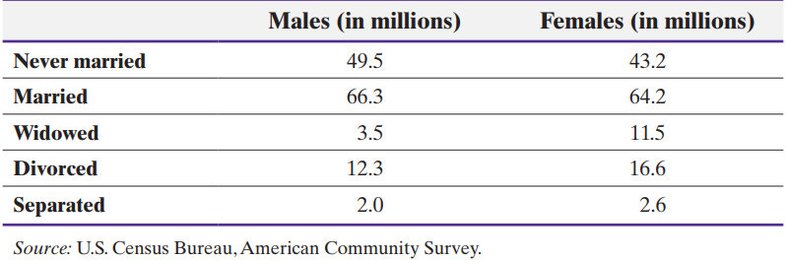

- Determine the probability that a randomly selected US resident 15 years old or older is male.
- Determine the probability that a randomly selected U.S. resident 15 years old or older is widowed.



- Determine the probability that a randomly selected U.S. resident 15 years old or older is widowed or divorced.
- Determine the probability that a randomly selected U.S. resident 15 years old or older is male or widowed.

Complement of an Event
Sometimes we want to find the probability of an event not occurring.
Definition: Let S denote the sample space of a probability experiment and let E denote an event. The complement of E,

Illustration of the Complement:

Example 14: According to the National Gambling Impact Study Commission, 52% of Americans have played state lotteries. What is the probability that a randomly selected American has not played a state lottery?

Example 15: In an effort to reduce the number of hospital-acquired conditions (such as infection resulting from the hospital stay), Medicare officials score hospitals on a 10-point scale with a lower score representing a better patient
track record. The federal government reduces Medicare payments to those hospitals with the worst scores. The following data represent the scores received by Illinois hospitals. Suppose we randomly select a hospital.

- What is the probability that the score is not between 9-10?
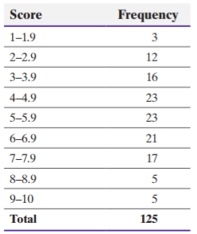
- What is the probability that the score is 2 or higher?

4.3 Independence and the Multiplication Rule
- In last section, we often knew the probability of “E and F” to find the probability of “E or F.” In this section, we will focus on if the probability of “E and F” is unknown.
- When calculating probabilities, it is useful if we know that two events are “independent.”
- Definition: Two events E and F are independent if

- Think about flipping a fair coin twice.
  - Does the fact that you obtained a head on the first toss have any effect on the likelihood of obtaining a head on the second toss?
  - It doesn’t so these two events would be considered independent.
- Think about rolling a six-sided die.
  - What is the probability of rolling a 6?
  - What if you know you rolled an even number?
  - Since the probability of rolling 6 changes once you know that you rolled a 4 or higher, these events would be considered dependent.
Example 16:
- Suppose you flip a coin and roll a die. Are the events “obtain a head” and “roll a 5” independent or dependent?
- Would you expect the events “earned a bachelor’s degree” and “earn more than $100,000 per year” independent?
- Two 24-year-old male drivers who live in the United States are randomly selected. Are the events “male 1 gets in a car accident during the year” and “male 2 gets in a car accident during the year” considered independent or dependent?

Multiplication Rule for Independent Events
- Suppose that you flip a fair coin twice. What is the probability that you obtain a head on both flips?
- If you listed all events in the sample space:

- What if we separated it out into two separate events:

Definition: If E and F are independent events, then

Example 17: The probability that a randomly selected 24-year-old male will survive the year is 0.9986 according to the National Vital Statistics Report, Vol. 56, No. 9.
- What is the probability that two randomly selected 24-year-old males will survive the year?
- What is the probability that three randomly selected 24-year-old males will survive the year?
- What is the probability that twenty randomly selected 24-year-old males will survive the year?

Computing At-Least Probabilities
- The phrase “at least” means “greater than or equal to.”
- When calculating “at least” probabilities, it’s often easier to use the rule of complements and set P(at least 1) = 1 – P(none). We will use an example to illustrate.
Example 18: Compute the probability that at least one male out of 1000 aged 24 years will die during the course of the year if the probability that a randomly selected 24-year-old male survives the year is 0.9986.

Example 19: Old Christmas lights are often designed with a series circuit. This means that when one light burns out the entire string of lights goes black. Suppose that the lights are designed so that the probability a bulb will last 2 years is 0.995.
The success or failure of a bulb is independent of the success or failure of other bulbs.
- What is the probability that in a string of 100 lights, all 100 will last two years?
- What is the probability that at least 1 bulb will burn out in 2 years?

4.4 Conditional Probability and the General Multiplication Rule
- In the last section, all probability calculations relied on events being independent. What happens if they’re dependent?
- For example, what’s the probability of getting in an accident if you drive to class? Well, that might depend on the weather conditions. It might be higher during a rainstorm than on a sunny day.
  - For example, the National Highway Safety Administration states that the probability of a randomly selected vehicle crash has a fatality is 0.0054.
  - However, among crashes which the driver is drowsy, that probability increases to 0.0196.
- If you are given some sort of information about an event occurring, then we can find the conditional probability of another event occurring.
- Definition:

Example 20: Suppose a single six-sided die is thrown. What is the probability that the die comes up a six? Now suppose that the die is rolled a second time, but we are told it was an even number. What is the probability that the die comes up a six?

Conditional Probability Rule
Refer to the example relating sex to marital status:
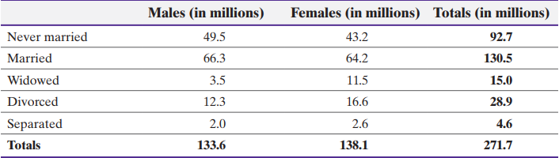

If we randomly selected someone, what’s the probability that they are widowed?

Suppose we know that the individual is female. How does that change the probability? Now, the sample space only includes females.

Definition: Conditional Probability Rule
If E and F are any two events, then:

Example 21: Refer back to the marital status example with the data below:

- Compute the probability that a randomly selected individual has never married, given they are male.
- Compute the probability that a randomly selected individual is male, given the individual has never married.

Example 22: Suppose that 12.7% of all births are preterm. (The gestation period of the pregnancy is less than 37 weeks.) Also 0.22% of all births resulted in a preterm baby who weighed 8 pounds, 13 ounces or more. What is the probability that a randomly selected baby weighs 8 pounds, 13 ounces or more, given that the baby is preterm? Is this unusual? Source: Vital Statistics Reports.

General Multiplication Rule
- Sometimes we know a conditional probability, but we want to find the probability of event E and event F occurring.
- Definition: General Multiplication Rule
The probability that two events E and F both occur is

Example 23: The probability that a driver who is speeding gets pulled over is 0.8. The probability that a driver gets a ticket, given that they are pulled over, is 0.9. What is the probability that a randomly selected driver who is speeding gets pulled over and gets a ticket?

Example 24: A common method in quality control is acceptance sampling. If you are manufacturing a certain item, then you want to ensure that items in a batch are not defective. However, checking an entire batch takes lots of time, effort, and money, so often times a few items are randomly selected to check if they’re defective.

Suppose that of 100 circuits sent to a manufacturing plant, 5 are defective.
The plant manager receiving the circuits randomly selects 2 and tests them. If both
circuits work, she will accept the shipment. Otherwise, the shipment is rejected. What is the probability that the plant manager discovers at least 1 defective circuit and rejects the shipment?

Example 25: In a study to determine whether preferences for self are more or less prevalent than preferences for others, researchers first asked individuals to identify the person who is most valuable and likeable to you, or your favorite other. Of the 1519 individuals surveyed, 42 had chosen themselves as their favorite other.

- Suppose we randomly select 1 of the 1519 individuals surveyed. What is the probability they chose themself as their favorite other?
- If two individuals from this group are randomly selected, what is the probability that both chose themselves as their favorite other?
- Compute the probability of randomly selecting two individuals from this group who selected themselves as their favorite other assuming independence.

Determining Independence
- Notice how parts (b) and (c) were close in value, regardless if you assumed independence or not.
- If small random samples are taken from large populations without replacement, it is reasonable to assume independence of the events. As a rule of thumb, if the sample size is less than 5% of the population size, we treat the events as independent.

Definition: Two events E and F are independent if

Example 26: Refer back to the marital status example with the data below:

If we randomly select an individual, are the events “widowed” and “female” independent?

4.5 Counting Techniques
- While counting techniques sounds like a simple concept, counting plays a major role in many diverse areas, including probability. Simply counting the number of ways you can do something can be deceptively difficult.
  - In fact, there’s a whole class about counting at UCF: MAD 4203 Introduction to Combinatorics (it has a prerequisite of calculus 2 and logic and proofs in mathematics, the course is no joke!)
- We will cover a few basic methods for probability calculations.

General Counting Principle
- Suppose you are at a fancy restaurant that gives you the following options for an appetizer, entrée, and dessert:
  - Appetizer
    - Soup
    - Salad
  - Entrée
    - Baked Chicken
    - Roasted beef au jus
    - Broiled beef patty
  - Dessert
    - Ice Cream
    - Cheesecake

Definition: Multiplication Rule of Counting
If a task consists of a sequence of choices in which there are p selections for the first choice, q selections for the second choice, r selection for the third choice, and so on, then

Example 27: The International Air Transport Association (IATA) assigns three-letter codes to represent airport locations. For example, the code for Fort Lauderdale International Airport is FLL. How many different airport codes are possible (assuming repeated letters are allowed)?

Example 28: Three members from a 14-member committee are to be randomly selected to serve as chair, vice-chair, and secretary. The first person selected is the chair, the second is the vice-chair, and the third is the secretary. How many different committee structures are possible?

- A symbol you may seen before in math is the factorial symbol, or “!”. In counting, we often have to use factorials.
- Definition: If n ≥ 0 is an integer (whole number), the factorial symbol, n!, is defined as:

Example 29: You have just been hired as a book representative. On your first day, you must travel to seven schools to introduce yourself. How many different routes are possible?

Permutations
- Examples 28 and 29 above are special cases of the multiplication rule of counting and are actually easier solved using permutations.
- Definition: A permutation is an ordered arrangement in which r objects are chosen from n distinct objects (such that r ≤ n). Repetition is not allowed (the same object cannot be selected twice). We use the following symbols and formula:

Example 30: Evaluate ₇P₅ and ₅P₅.

Using Excel:
=PERMUT(n, r)

In the examples above,
=PERMUT(7, 5)
=PERMUT(5, 5)

Example 31: Consider a race with 10 runners. How many ways can 10 runners finish first, second, and third?

Combinations
- In permutations, order mattered (so selecting ABC is different than BAC).
- Sometimes, we don’t care about order. For example, in poker, we don’t care about the order in which the cards are received.

Definition: A combination is a collection, without regard to order, in which r objects are chosen from distinct objects (with r ≤ n). We use the following notation and formula:

In Excel:

=COMBIN(n, r)

Example 32: Roger, Ken, Tom, and Jay are going to play golf. They will randomly select teams of two players each. How many ways can teams be selected? List all possible combinations, then use the combinations formula.

Example 33: How many different simple random samples of size 4 can be obtained from a population whose size is 20?

Using Counting Methods in Probability Calculations
- In probability, we can use counting to count the total number of outcomes for a certain probability experiment. We can count the number of outcomes in the numerator and then divide by the total number of outcomes.

Example 34: In the Missouri Lottery, an urn contains balls numbered 1–44. From this urn, six balls are randomly chosen without replacement. For a $1 bet, a player chooses two sets of six numbers. To win, all six numbers must match those chosen from the urn. The order in which the balls are picked does not matter. What is the probability of winning the lottery?

Example 35: Consider a standard deck of 52 cards. You are dealt 4 cards. What is the probability that all 4 cards match? Solve this by answering the questions below.
- How many ways can 4 cards be selected from a 52-card deck?
- Of all the possible hands listed in part (a), how many of them have all 4 cards that match?
- What is the probability that all 4 cards match?

- How you know what method to use?
  - If you are making a sequence of choices: use Multiplication Rule of Counting
  - If you are choosing r objects of a total of n objects:
    - If order matters, use permutation.
    - If order doesn’t matter, use combination.

4.7 Determining Which Method to Use
- We just covered a lot of probability rules and counting techniques. When you go to solve a problem, often times you will not be directly given the technique you should use. How do you determine that?
- Often times, there are multiple ways to the correct answer, but certain methods are easier than other. You can use the flow diagram below to determine what rule should be used.

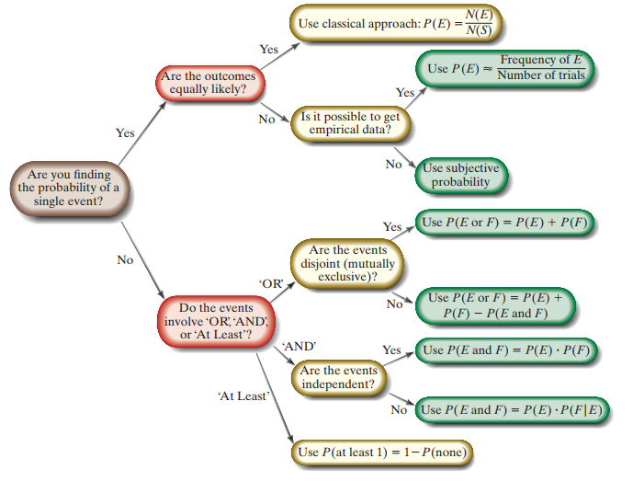

- What about counting techniques?
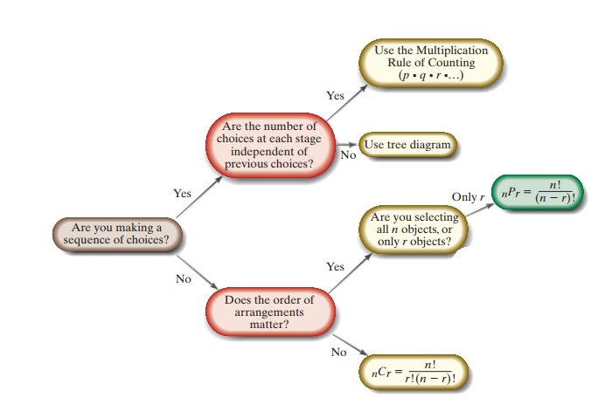
Note: there are other counting techniques discussed in 5.5, but these are just the ones we covered.

Recall that for Excel:

- Permutations
  - =PERMUT(n, r)
- Combinations
  - =COMBIN(n, r)

